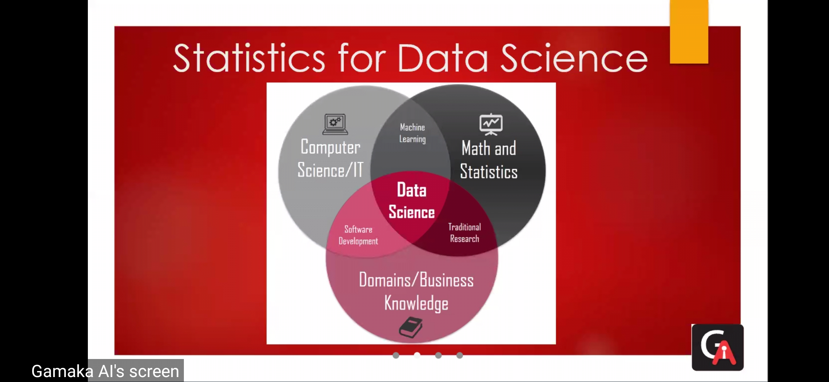

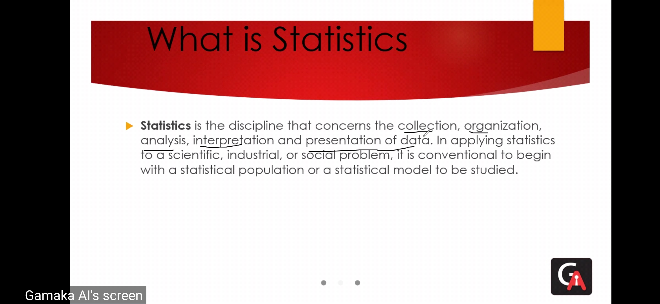

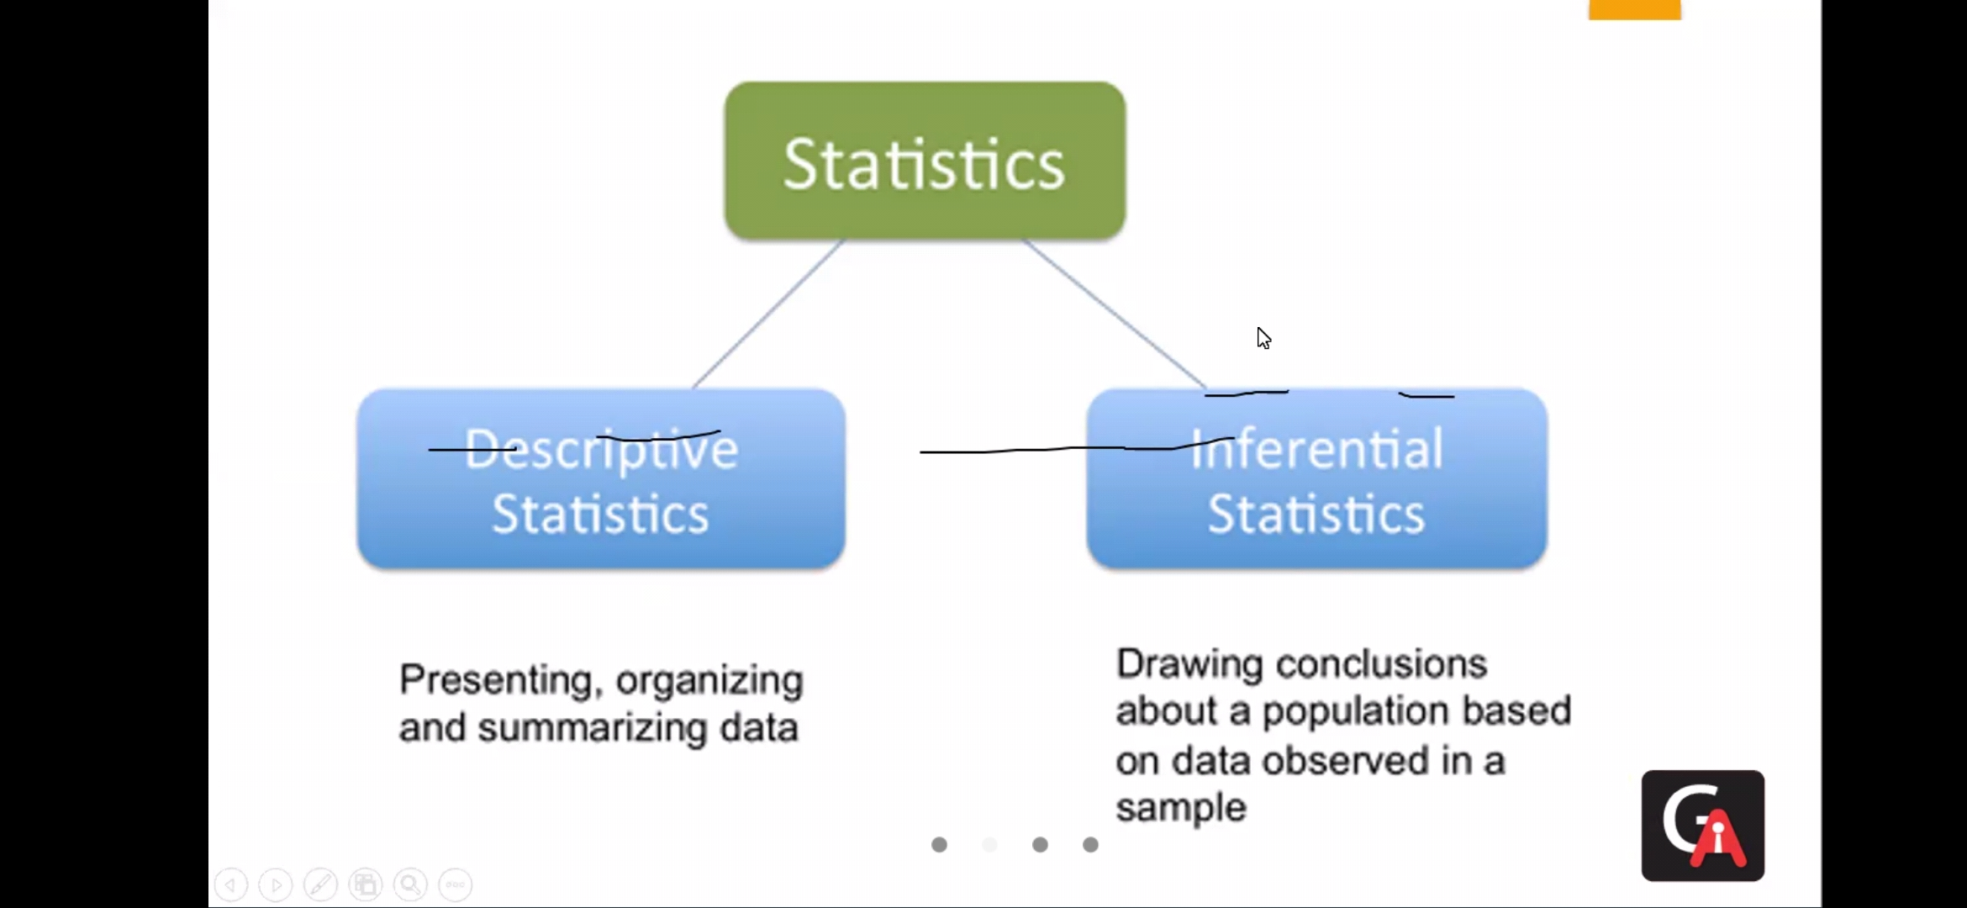

descriptive data - simple things done on date ( summary of data )

inference - conclusion of data

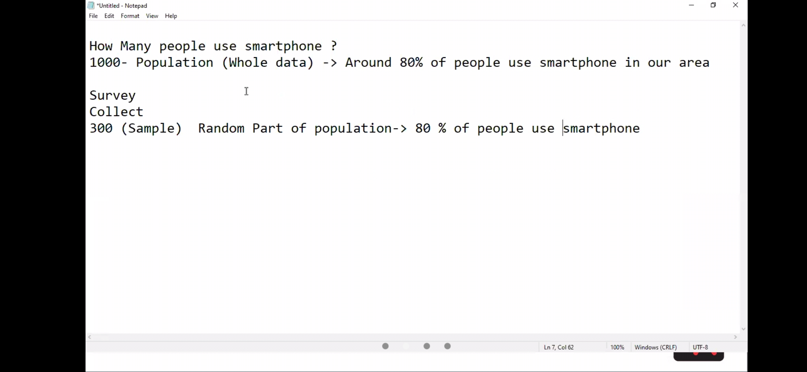

we cannot gone through all data , so they conclude with sample ( some part of whole )

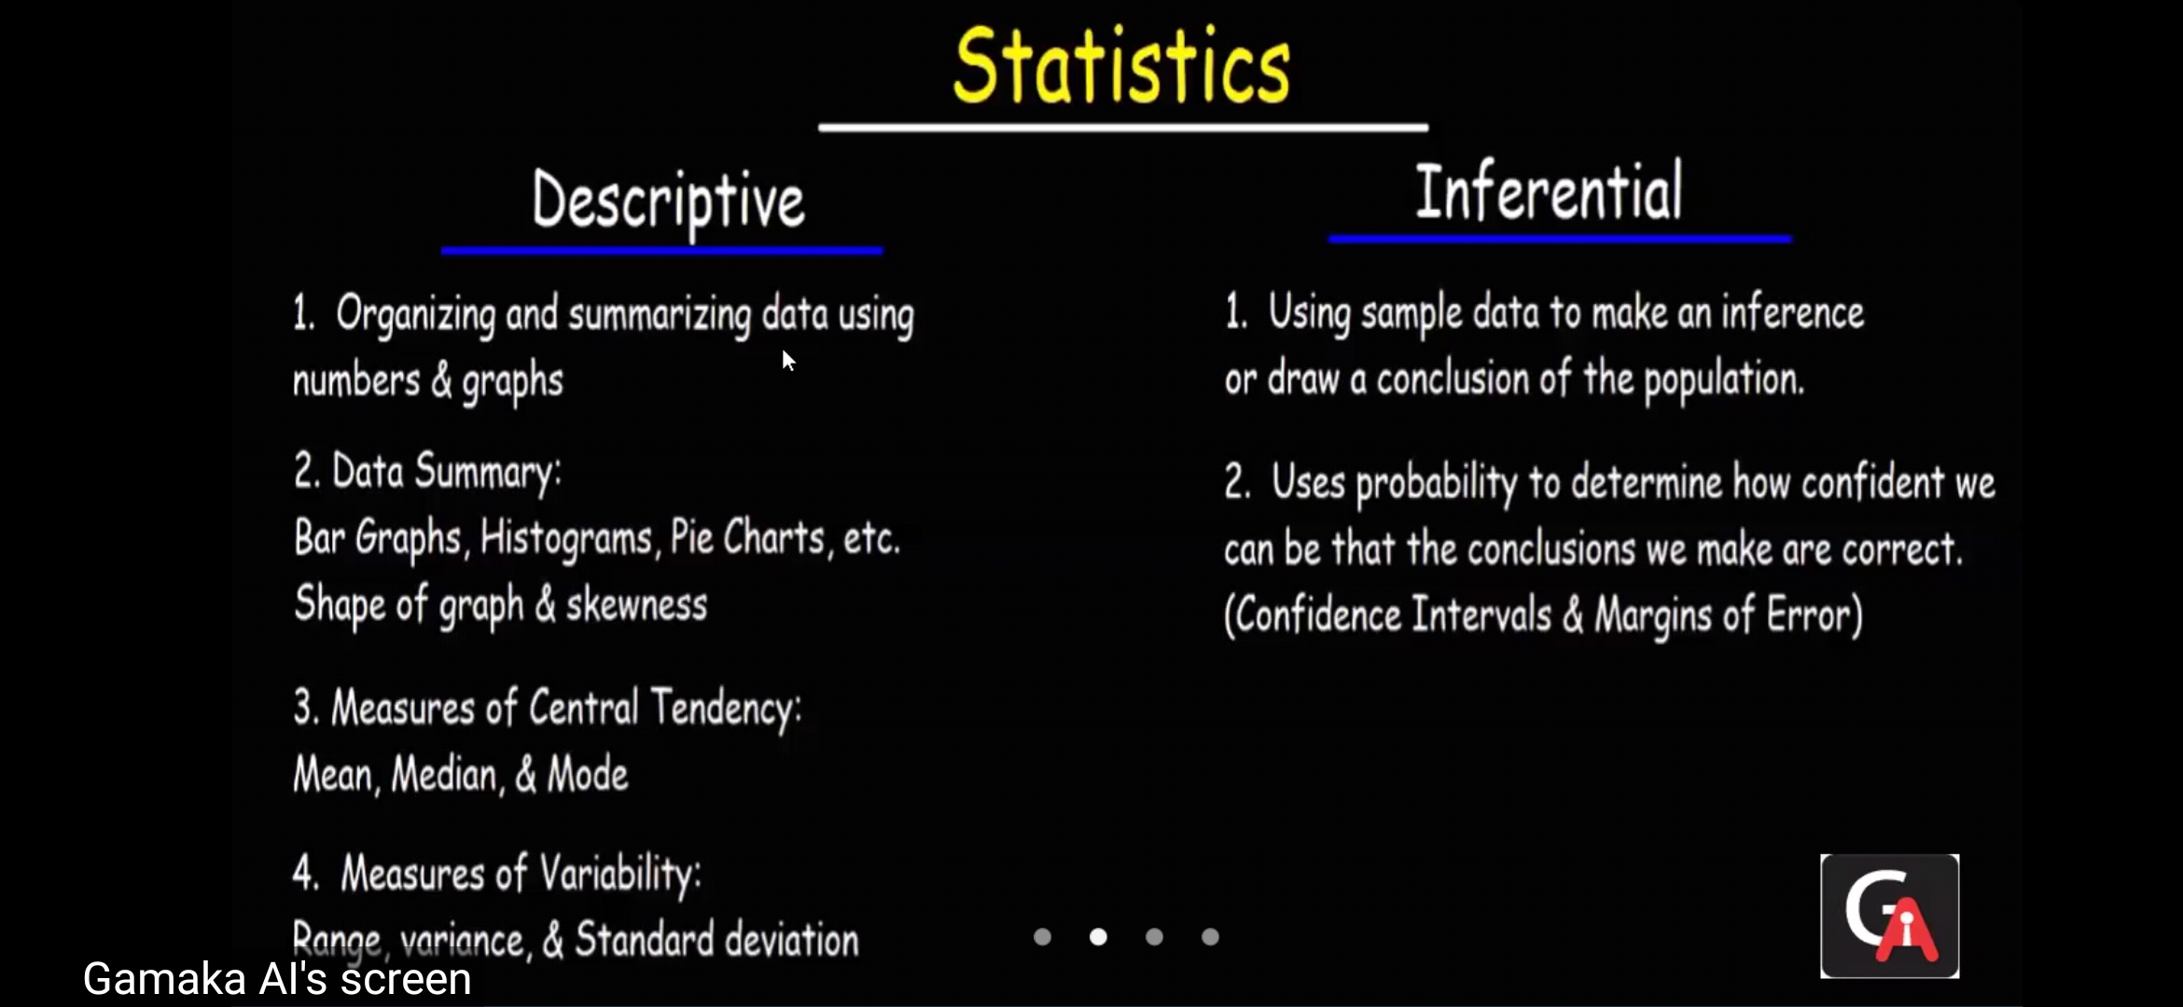

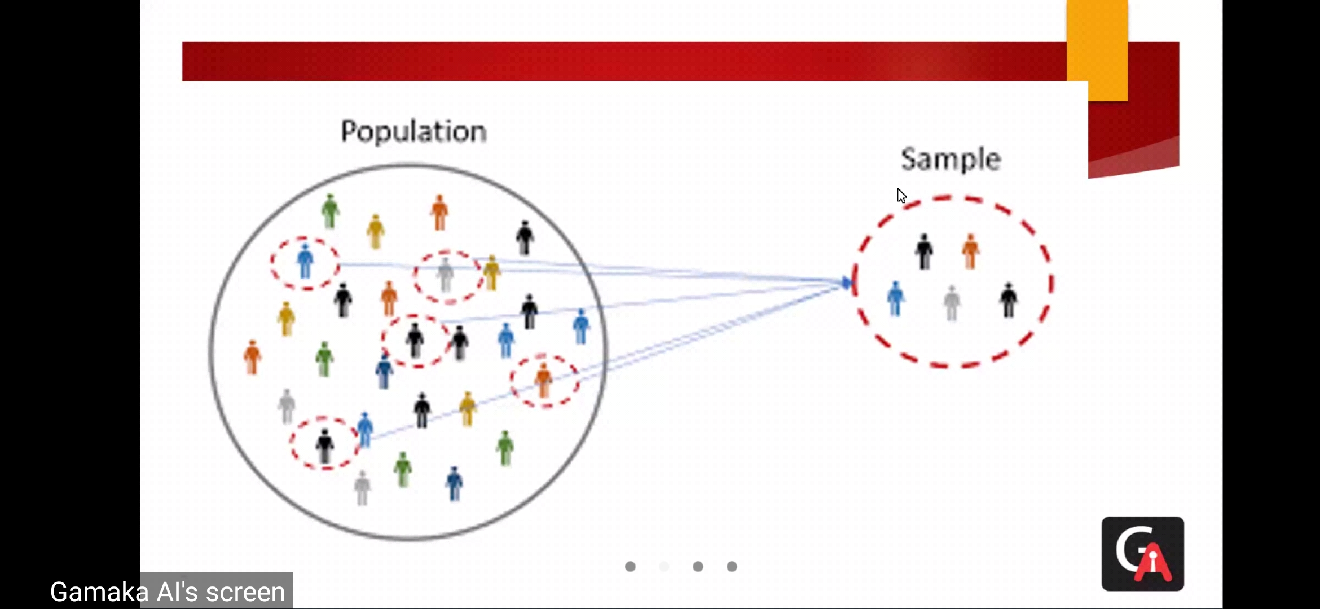

but sometimes population can vary based on senario , that's why we go for samples …

in statistics - mainly data was structured..

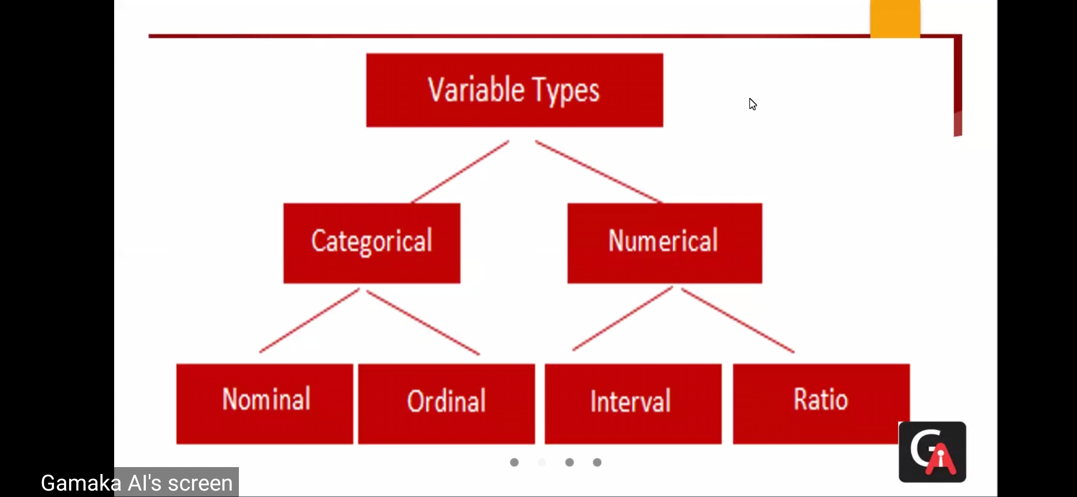

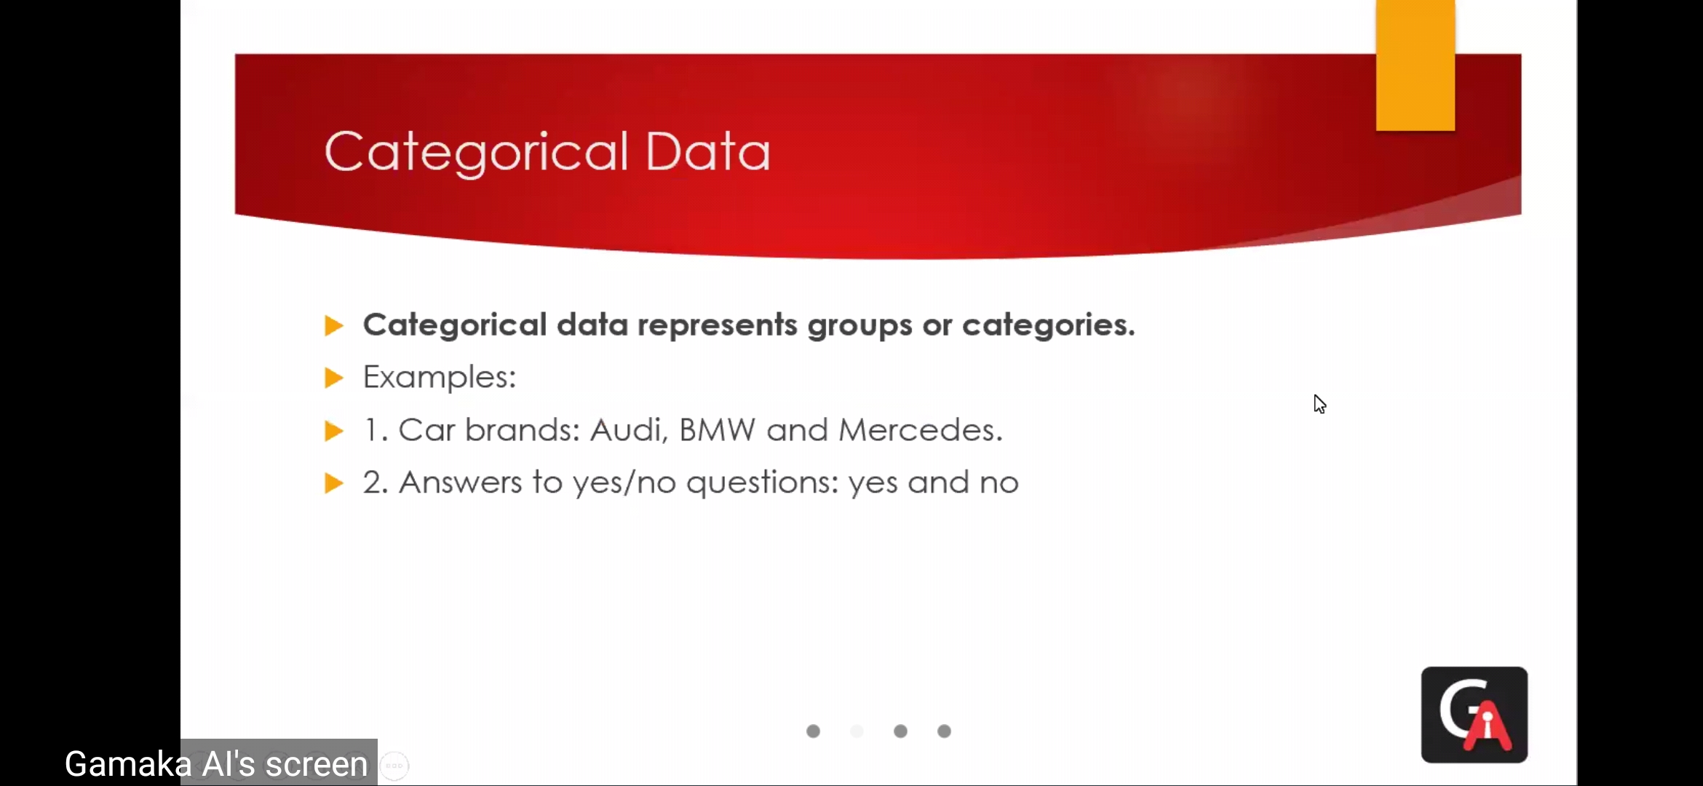

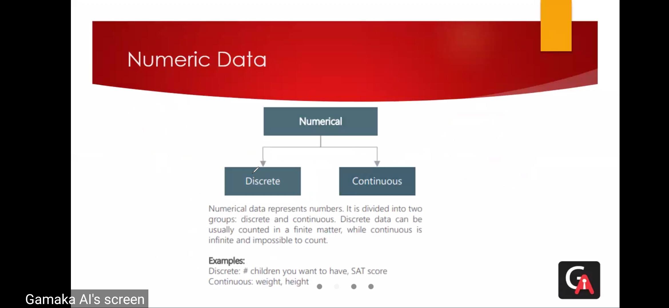

discrete - finite, whole number

continues - infinite , any range , also include fractions

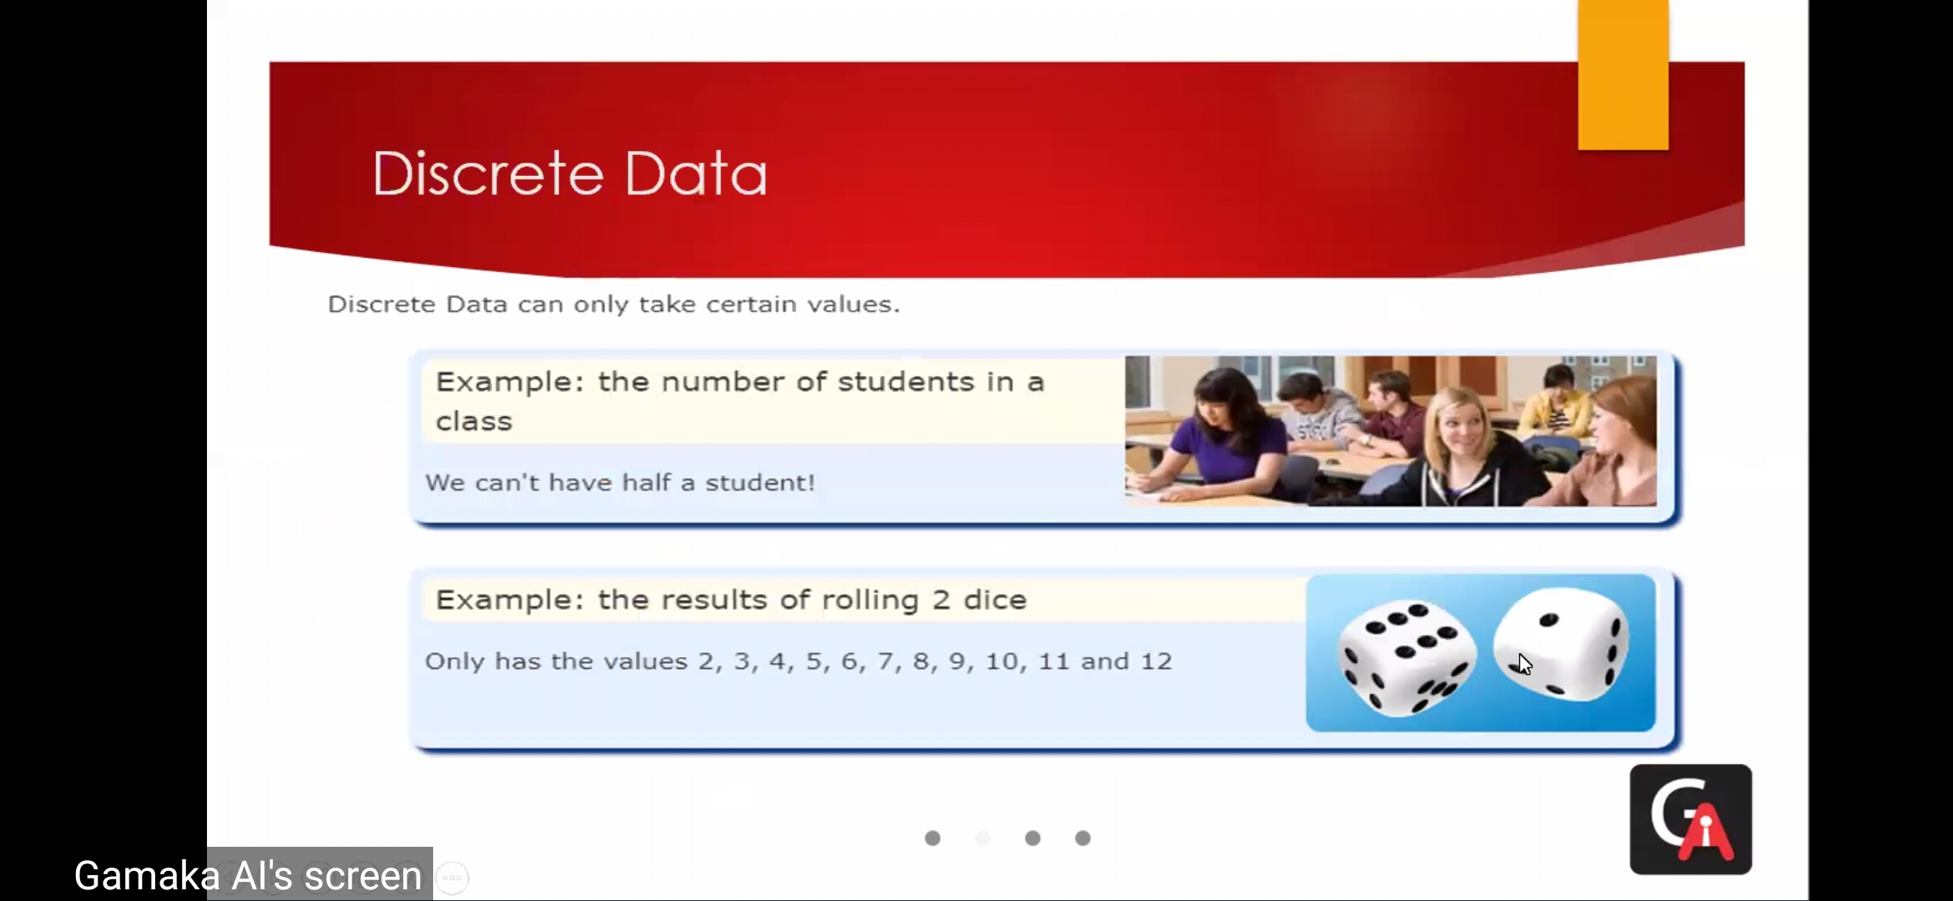

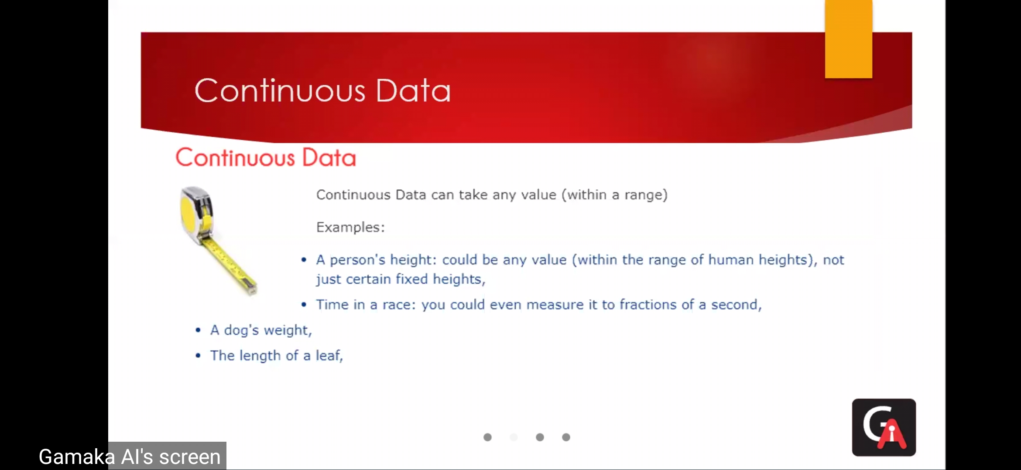

age :

\*discrete - 28 years

\*continues - 28years 3 months.. etc..

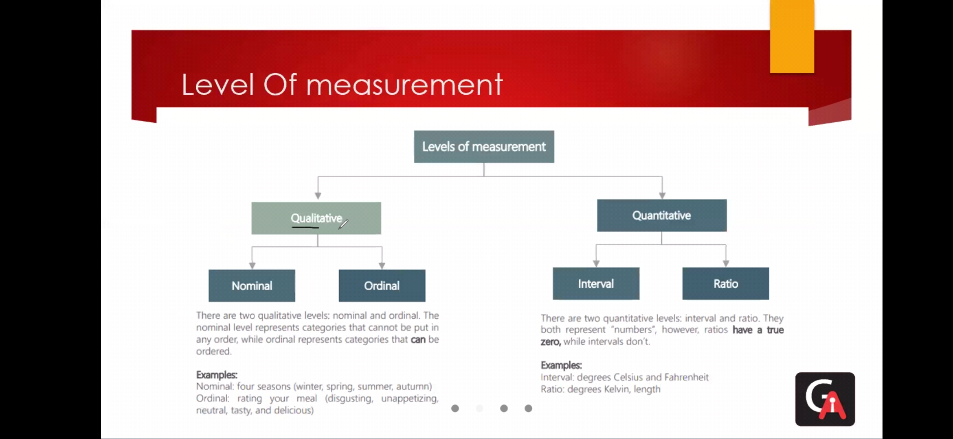

Qualitative :

Norminal - name - labelling

Ordinal - order - gives intensity

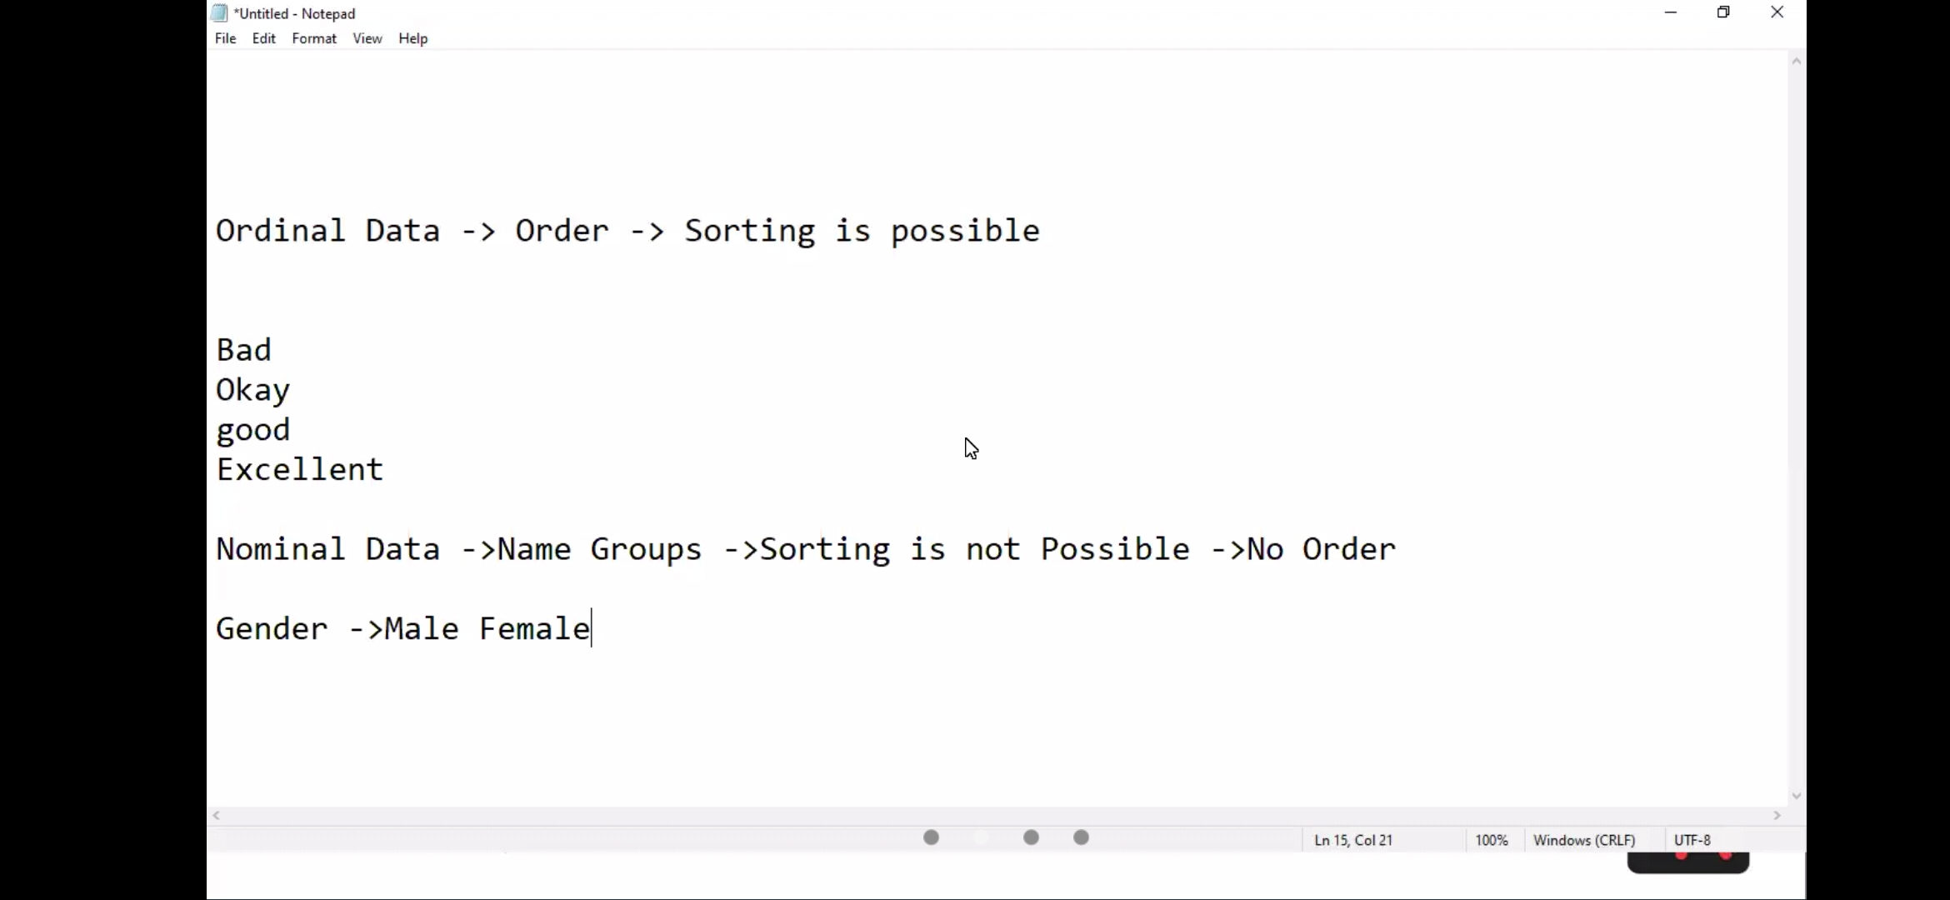

Quantitative :

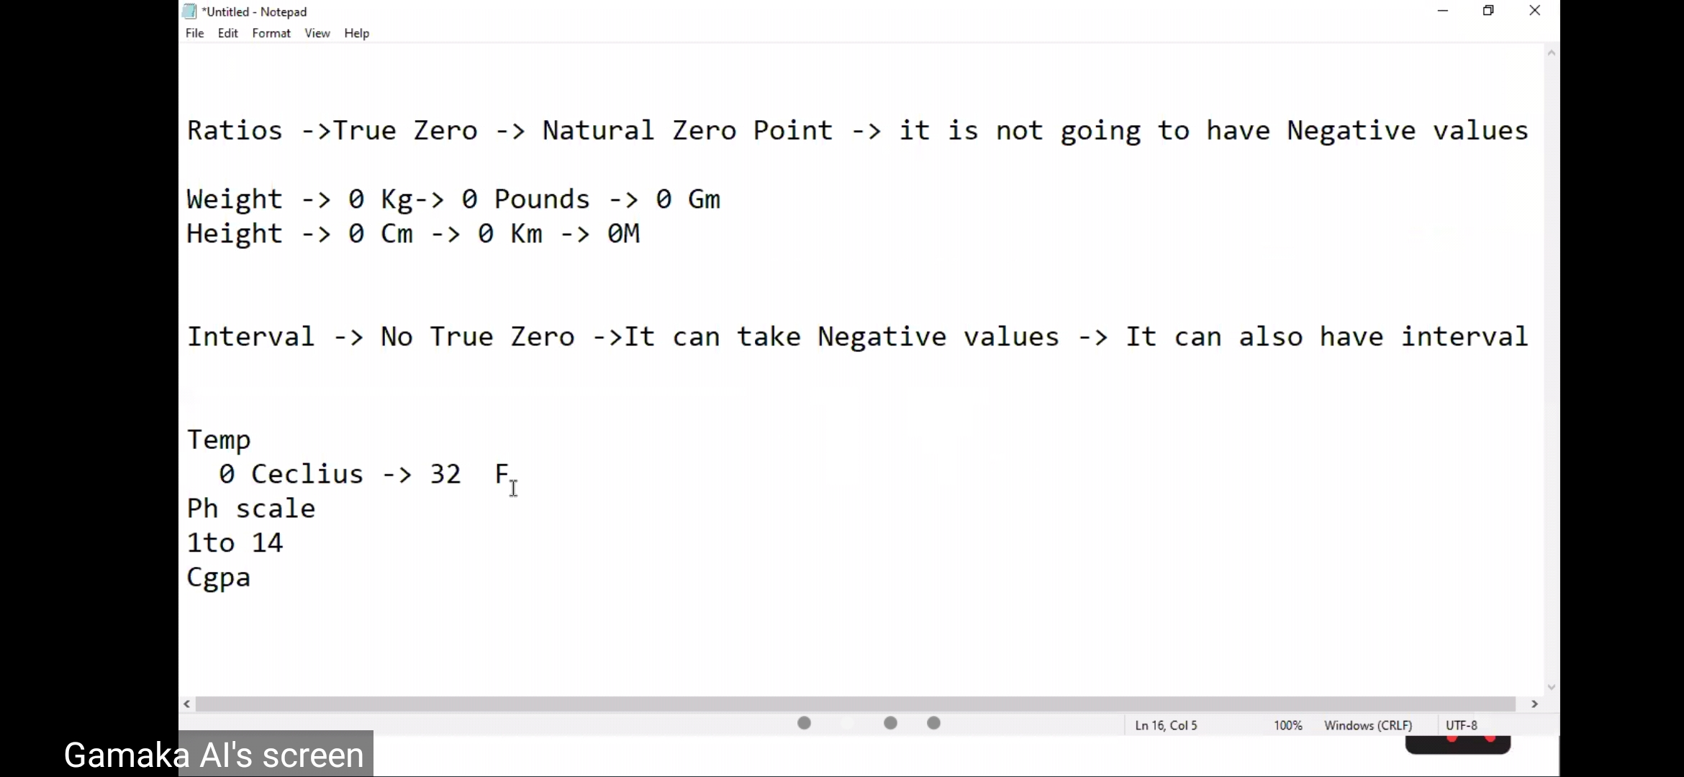

Statistic - used in machine learning model…

Here we can understand the maths statistics formula….